REPORT Nº 0110

EQUIPMENT : MEMO SAFE , DATA RECORDER
UNIT : ENTIRE FLEET OF BUSES BONLUCK / HUANGHAI
DATE : 13/04/2011

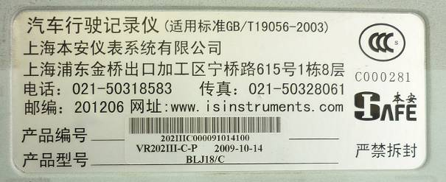
Equipment name

Problem:
The Memo Data Recorder, after working for a period o 1 to 2 months becomes inactive. When this happens one is no longer able to see the digits in the screen and only the green background light remains on, even when one has turned the ignition key off.

When the Memo Data Recorder is in this condition, it blocks the start of the engine with the ignition key which forces the operator to turn the engine on using the emergency button located in the engine compartment in the back. This poses a serious risk to the operator.

This condition affects 80% of the fleet of buses produced by Bon Luck / Modasa.

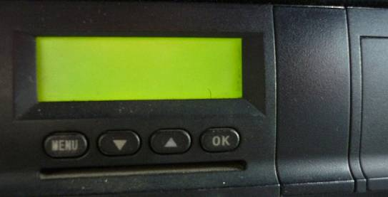
View of a blocked Memo Data Recorder

Re-programming
At the moment, the only way we have to unblock this situation is by executing the following procedure:
- Disconnect the Memo Box
- Leave it disconnected for at least 8 hours
- Re-program the Memo Data Recorder with the software and the Card given to us by Mr. Wang in August of 2010.

NOTE
During all of 2010 we were re-programming the Memo Data Recorder with version xxxxx69 of the software. At that time we noticed that, when we used this version, the blockage occurred after approximately 1 month.
On January 5 of 2011, we started using version 0083171 of the memo software which was given to us by Ms. Sophia in December 2010. With this new software, we noticed that the blockage occurred only after about 2 months.

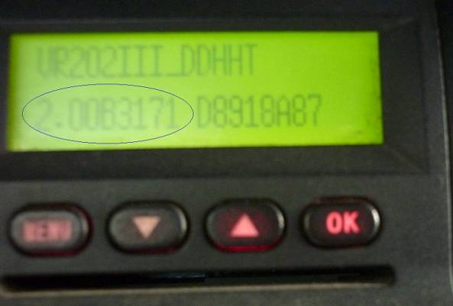
Software version with blockage period of 2 months (0083171)

URGENT PROBLEM:
Last week, the only card that allowed us to re-program the Memo Data Recorder, broke. We now have no means of doing the re-programming. This is a big problem because now 80% of the fleet must started with the emergency button. We urgently require that you send us a new card, preferably 5 or 6 of them, so we can do the re-programming.

Further Observations

- We are assuming that the blockage of the starting of the bus is due to a problem in the Memo Data Recorder. Certainly the re-programming of the Memo Box confirms this idea.
- It is very possible that the blockage occurs due to the saturation of the memory in the Memo Box.
- The idea that the saturation of the memory is the problem is supported by the fact that, out of the 23 registers of information that the Memo collects, 9 are defined as ¨permanent” (see document attached). This would indicate that these registers cannot be erased until they are dumped or read.
- Until now, because the deployment of the fleet is so new, we have not implemented a procedure for systematic reading or dumping of the memory which means that it is very possible that the memory is filling up until saturation occurs.
- Nevertheless, it is a problem that needs to be solved in a permanent way. We do not consider that saturation of the memory should lead to the blockage of a bus. The correct thing to do when saturation occurs is that a message is displayed in the memo screen indicating that no data will be collected because the registers are full. Even better, a warning could be displayed when about 80% of the memory is used – before saturation occurs. Either way, the ignition system must never be blocked because this only makes the problem worse.
- It is also important to mention that some of the buses of the fleet, due to scheduling and route issues, may run continuously for up to 18 hours without being turned off even if the drivers change. Other buses may only run for 5 or 6 hours.

It is clear that the problem described above is not just a critical operational problem but also a risk of personal injury to the operators which could lead to catastrophic consequences. We urgently require that you send us the cards via DHL or the fastest possible way and that the problem is analyzed with a permanent solution in mind. We also require that you name a permanent representative here in Peru so problems affecting the CAN bus and the bus components can be addressed quickly, effectively and permanently.

Best regards,

Reuly Huapaya
MODASA

